***PROJECT REPORT TEMPLATE***

***1 INTRODUCTION:***

***1.1OVERVIEW:***

1. ***Define your requirements: First, you need to define your requirements and goals for implementing the CRM system. This will include defining the data you need to collect and track, as well as the features you require to manage this data effectively.***
2. ***Select a CRM system: Once you have defined your requirements, you need to select a CRM system that meets your needs. There are many CRM systems available in the market, so you need to choose the one that provides the required features and functionalities.***

***PURPOSE:***

***Define your requirements: First, define your requirements for the CRM system. This includes the data you need to collect, how you want to track the candidate's progress, and the types of reports you want to generate.***

***Choose a CRM platform: Next, choose a CRM platform that meets your requirements. There are many CRM platforms available, both free and paid, that offer different features and functionalities. Some popular options include Salesforce, HubSpot, Zoho CRM, and Microsoft Dynamics 365.***

***2 PROBLBM DEFINITION & DESIGN THINKING***

***EMPATHY MAP***

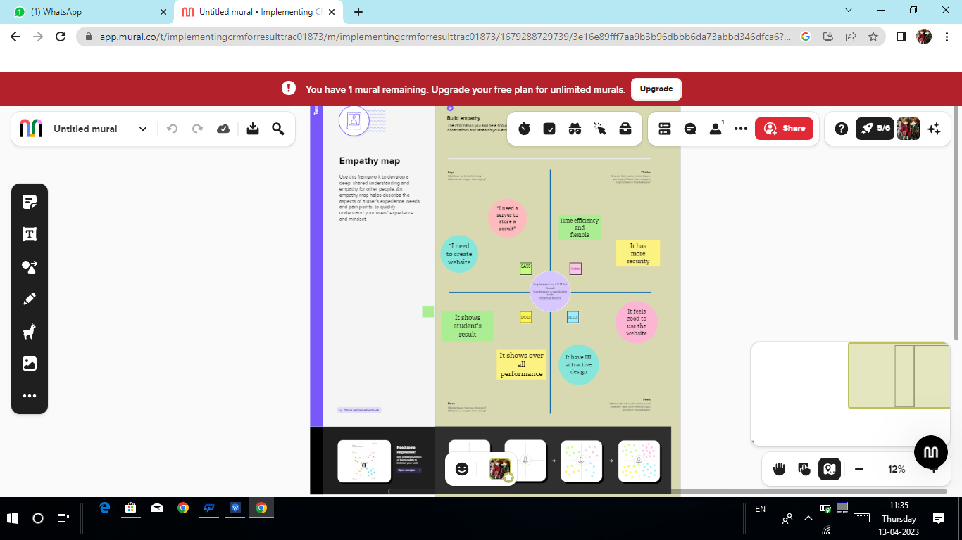

***IDEATION& BRAINSTORMING MAP***

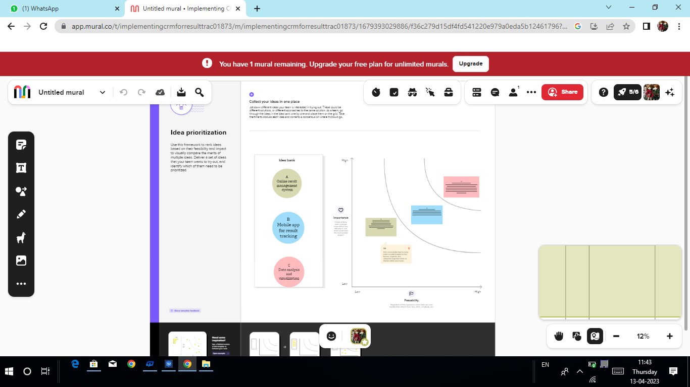

***3 RESULT:***

***DATA MODEL***

|  |  |  |  |  |
| --- | --- | --- | --- | --- |
| ***SEMESTER*** | ***CANDIDATE*** | ***COURSE***  ***DETAILS*** | ***LECTURER***  ***DETAILS*** | ***INTERNAL***  ***RESULTS*** |
| ***Semester name*** | ***Candidate name*** | ***Course name*** | ***Lecturer role*** | ***Candidate results*** |
| ***Course(lookup)*** | ***Candidate id*** | ***Course id*** | ***Lecturer name*** | ***Course id*** |
|  | ***Semester name*** |  | ***Course id*** | ***Marks*** |
|  | ***Internal results(lookuo)*** |  | ***Course(lookup)*** |  |

***ACTIVITY & SCREENSHOT:***

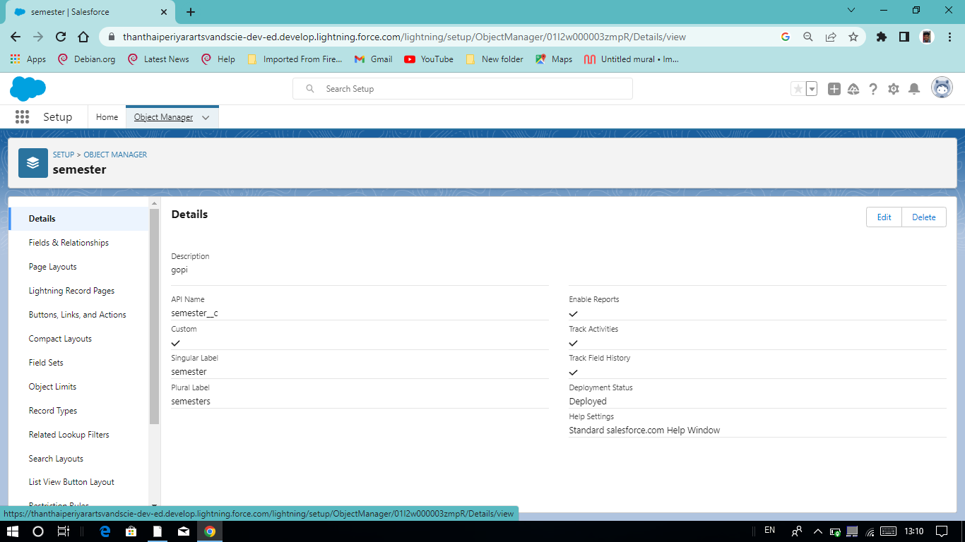

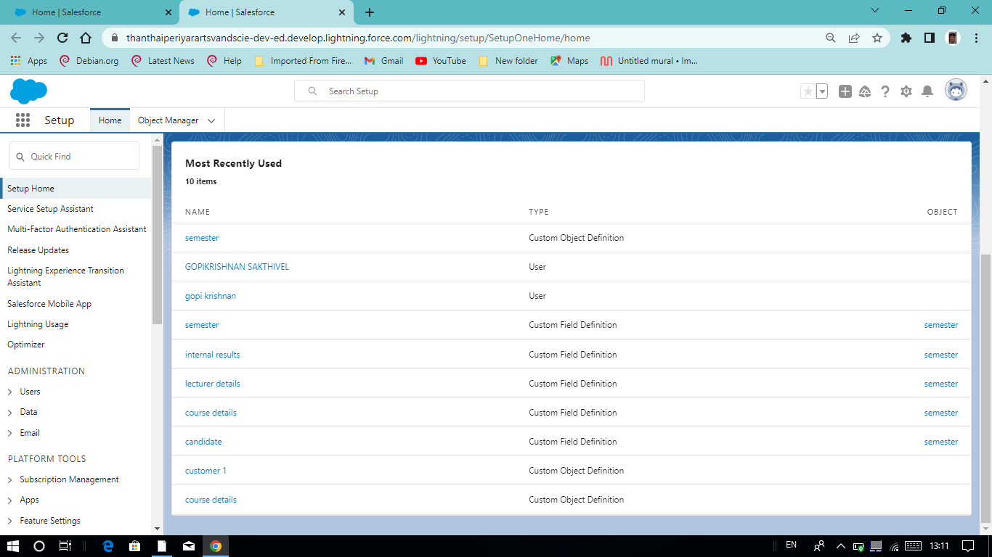

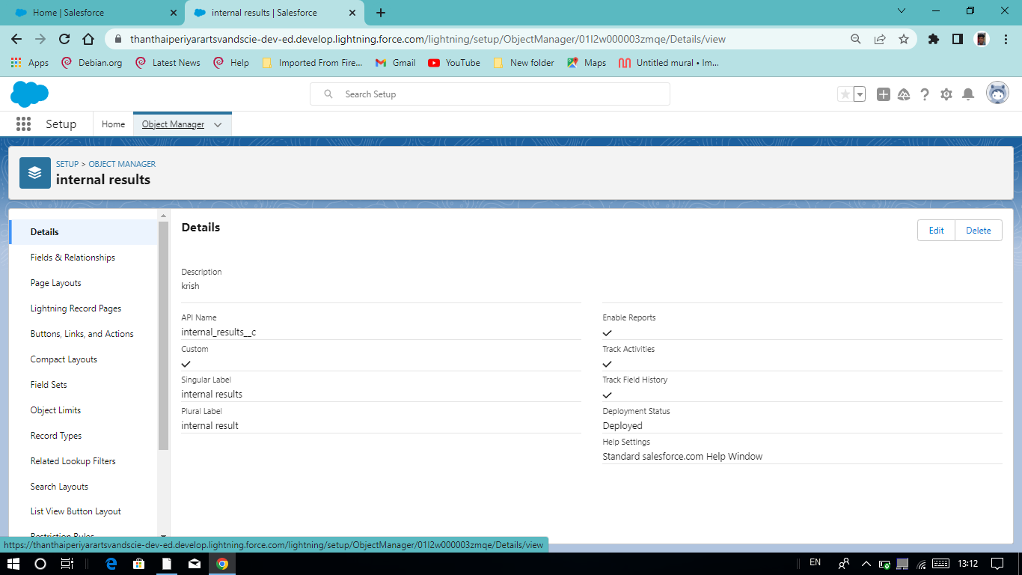

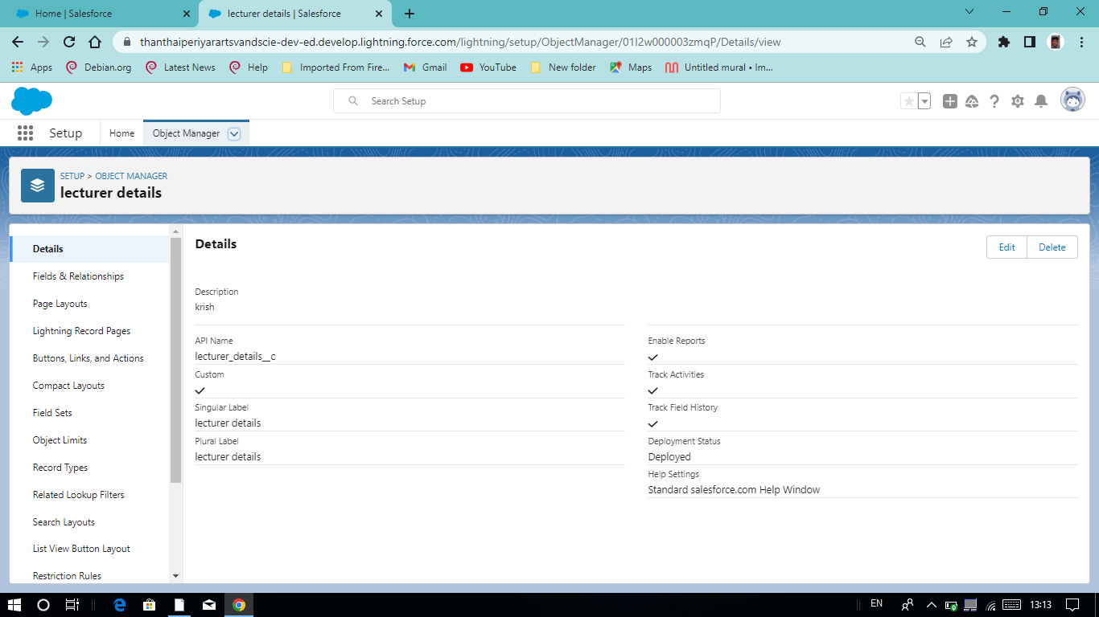

***4 TRAILHEAD PROFILE PUBLIC URL;***

***TEAM LEADER - https://trailblazer.me/id/gsakthivel6***

***TEAM MEMBER 1- https://trailblazer.me/id/gjayaraman***

***TEAM MEMBER 2- https://trailblazer.me/id/hmuruganandam***

***TEAM MEMBER 3- https://trailblazer.me/id/grengasamy2***

***5 ADVANTAGES & DISADVANTAGE***

***ADVANTAGES***

***Define your objectives: Determine the specific goals you want to achieve with your CRM system. This could include tracking student performance, identifying areas for improvement, and analyzing trends in student behavior.***

***Choose the right CRM software: Select a CRM software that is suited for education institutions and can track student performance, such as Salesforce or Hubspot.***

***DISADVANTAGE***

***Identify alternative data sources: If internal marks are not available, you will need to find alternative data sources to track the candidate's progress. Some options may include performance in mock exams, attendance records, participation in extra-curricular activities, or feedback from teachers or mentors.***

***Define relevant metrics: Once you have identified the data sources, you will need to define relevant metrics to track the candidate's progress. For example, you may want to track the number of mock exams taken, the average score in these exams, the number of extracurricular activities participated in, or the feedback received from teachers or mentors.***

***6 UPPLICATION***

***Identify the key data points: Determine the key data points that need to be tracked in the CRM, such as candidate name, internal marks, course name, semester, etc.***

***Choose a CRM software: Select a CRM software that meets your requirements. Some popular options are Salesforce, HubSpot, and Zoho CRM.Set up the CRM: Create custom fields in the CRM for the data points you identified in step 1. This will allow you to store and track the data efficiently.***

***7 CONCLUSION***

***Choose a CRM platform: There are many CRM platforms available in the market, such as Salesforce, Hubspot, Zoho, etc. Choose a CRM platform that suits your budget and requirements.Customize the CRM: Once you have selected a CRM platform, customize it to meet your specific needs. Add fields for candidate information such as name, email, phone number, and other relevant details.Add internal marks tracking: Create a section in the CRM where you can enter the internal marks of the candidate. This could be a separate field or a custom module within the CRM.***

***8 FUTURE SCOPE***

***Identify the requirements: First, identify the requirements of the CRM system. This includes the data that needs to be collected, how it will be collected, and how it will be used.***

***Choose a CRM system: Next, choose a CRM system that is suitable for the requirements. There are many CRM systems available, such as Salesforce, HubSpot, Zoho CRM, and others.***

***Configure the CRM system: After selecting a CRM system, configure it to meet the requirements. This includes setting up the database, customizing fields, and creating workflows.***